Steps for Checking
A purchase Order
For Receipts

When entering an accounts payable invoice and an error occurs that says,

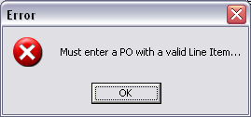

Check the following:

- Were there any receipts entered for that purchase order?
  - To check this you can check multiple reports.
    - M-R-7 (Material Receipts History). Enter the Item# in the search for the correct date range. Select all material types. This will display all receipts for that item for that date range. If you see your receipts here then everything was received. If they do not display here then you need to enter the receipts for this purchase order before being able to enter the accounts payable invoice.
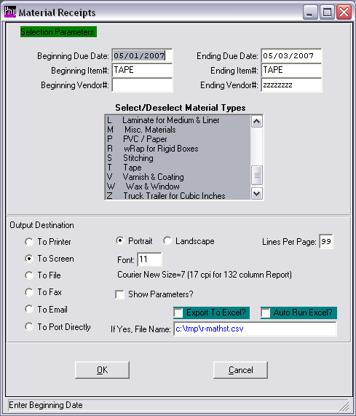

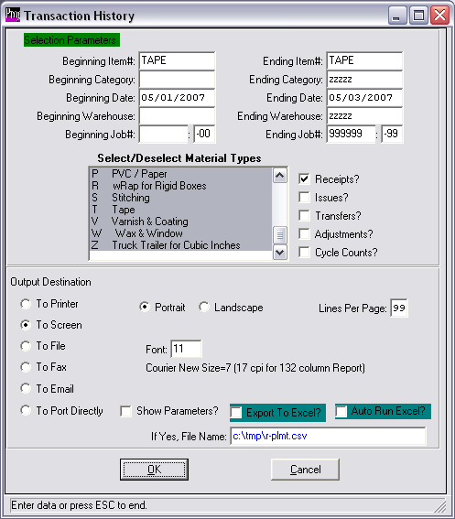
    - M-R-5 (Transaction History). Enter the Item# in the search for the correct date range. Select all material types. Check off the receipts box on the screen. This will display all receipts for that item for that date range. If you see your receipts here then everything was received. If they do not display here then you need to enter the receipts for this purchase order before being able to enter the accounts payable invoice.

- Has the Purchase Order already been invoiced.
  - To check this you can look at the Purchase Order Inquiry screen (P-Q-1).
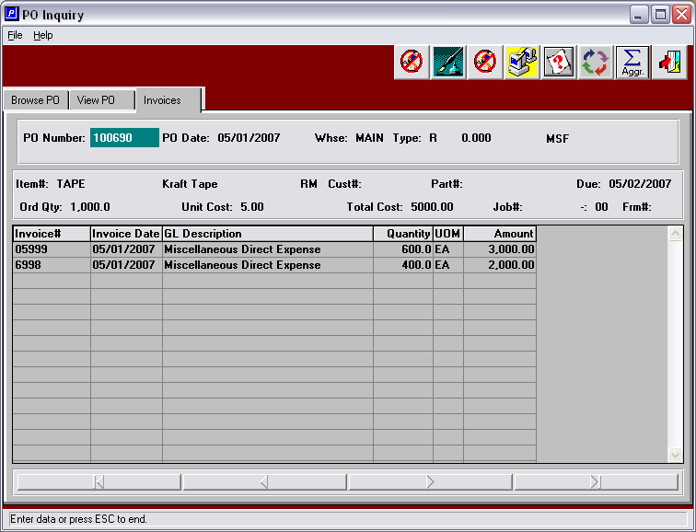
  - Enter the purchase order and look at the Invoices Tab. If this screen is blank, then the purchase order has not been invoiced yet. Check to see if the purchase order has receipts by going through the steps in step 1.

